**本实例使用了三台虚拟机部署kafka集群**

192.168.31.21 node1

192.168.31.22 node2

192.168.31.23 node3

**node1.yml**

|  |
| --- |
| version: '3'  services:  zoo:  image: 'bitnami/zookeeper:latest'  user: root  restart: unless-stopped  hostname: zoo  container_name: zoo  ports:  - 2181:2181  - 2888:2888  - 3888:3888  volumes:  - /docker/data/zookeeper:/bitnami/zookeeper  environment:  ZOO_SERVER_ID: 1  ZOO_SERVERS: 0.0.0.0:2888:3888,192.168.31.22:2888:3888,192.168.31.23:2888:3888  ALLOW_ANONYMOUS_LOGIN: 'yes'  kafka:  image: 'bitnami/kafka:latest'  user: root  restart: unless-stopped  hostname: kafka  container_name: kafka  ports:  - 9092:9092  environment:  KAFKA_ADVERTISED_HOST_NAME: 192.168.31.21  KAFKA_HOST_NAME: 192.168.31.21  KAFKA_ADVERTISED_PORT: 9092  KAFKA_BROKER_ID: 1  KAFKA_CFG_ZOOKEEPER_CONNECT: 192.168.31.21:2181,192.168.31.22:2181,192.168.31.23:2181  KAFKA_CFG_ADVERTISED_LISTENERS: PLAINTEXT://192.168.31.21:9092  KAFKA_CFG_LISTENERS: PLAINTEXT://:9092  ALLOW_PLAINTEXT_LISTENER: 'yes'  KAFKA_CFG_AUTO_CREATE_TOPICS_ENABLE: 'true'  volumes:  - /docker/data/kafka:/bitnami/kafka |

**node2.yml**

|  |
| --- |
| version: '3'  services:  zoo:  image: 'bitnami/zookeeper:latest'  user: root  restart: unless-stopped  hostname: zoo  container_name: zoo  ports:  - 2181:2181  - 2888:2888  - 3888:3888  volumes:  - /docker/data/zookeeper:/bitnami/zookeeper  environment:  ZOO_SERVER_ID: 2  ZOO_SERVERS: 192.168.31.21:2888:3888,0.0.0.0:2888:3888,192.168.31.23:2888:3888  ALLOW_ANONYMOUS_LOGIN: 'yes'  kafka:  image: 'bitnami/kafka:latest'  user: root  restart: unless-stopped  hostname: kafka  container_name: kafka  ports:  - 9092:9092  environment:  KAFKA_ADVERTISED_HOST_NAME: 192.168.31.22  KAFKA_HOST_NAME: 192.168.31.22  KAFKA_ADVERTISED_PORT: 9092  KAFKA_BROKER_ID: 2  KAFKA_CFG_ZOOKEEPER_CONNECT: 192.168.31.21:2181,192.168.31.22:2181,192.168.31.23:2181  KAFKA_CFG_ADVERTISED_LISTENERS: PLAINTEXT://192.168.31.22:9092  KAFKA_CFG_LISTENERS: PLAINTEXT://:9092  ALLOW_PLAINTEXT_LISTENER: 'yes'  KAFKA_CFG_AUTO_CREATE_TOPICS_ENABLE: 'true'  volumes:  - /docker/data/kafka:/bitnami/kafka |

**node3.yml**

|  |
| --- |
| version: '3'  services:  zoo:  image: 'bitnami/zookeeper:latest'  user: root  restart: unless-stopped  hostname: zoo  container_name: zoo  ports:  - 2181:2181  - 2888:2888  - 3888:3888  volumes:  - /docker/data/zookeeper:/bitnami/zookeeper  environment:  ZOO_SERVER_ID: 3  ZOO_SERVERS: 192.168.31.21:2888:3888,192.168.31.22:2888:3888,0.0.0.0:2888:3888  ALLOW_ANONYMOUS_LOGIN: 'yes'  kafka:  image: 'bitnami/kafka:latest'  user: root  restart: unless-stopped  hostname: kafka  container_name: kafka  ports:  - 9092:9092  environment:  KAFKA_ADVERTISED_HOST_NAME: 192.168.31.23  KAFKA_HOST_NAME: 192.168.31.23  KAFKA_ADVERTISED_PORT: 9092  KAFKA_BROKER_ID: 3  KAFKA_CFG_ZOOKEEPER_CONNECT: 192.168.31.21:2181,192.168.31.22:2181,192.168.31.23:2181  KAFKA_CFG_ADVERTISED_LISTENERS: PLAINTEXT://192.168.31.23:9092  KAFKA_CFG_LISTENERS: PLAINTEXT://:9092  ALLOW_PLAINTEXT_LISTENER: 'yes'  KAFKA_CFG_AUTO_CREATE_TOPICS_ENABLE: 'true'  volumes:  - /docker/data/kafka:/bitnami/kafka |

其中ZOO_SERVERS必须按顺序，不能改变，否则报错

**JMX监控kafka**

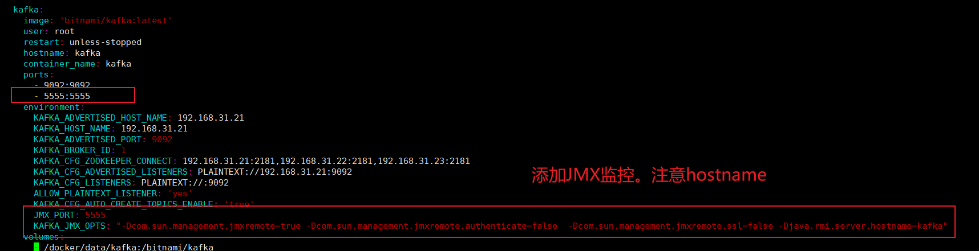

|  |
| --- |
| JMX_PORT: 5555  KAFKA_JMX_OPTS: "-Dcom.sun.management.jmxremote=true -Dcom.sun.management.jmxremote.authenticate=false -Dcom.sun.management.jmxremote.ssl=false -Djava.rmi.server.hostname=kafka" |

**kafka-manager.yml**

|  |
| --- |
| version: '3.1'  services:  kafka-manager:  image: sheepkiller/kafka-manager  restart: always  hostname: kafka-manager  container_name: kafka-manager  ports:  - 9000:9000  environment:  ZK_HOSTS: 192.168.31.21:2181,192.168.31.22:2181,192.168.31.23:2181  KAFKA_BROKERS: 192.168.31.21:9092,192.168.31.22:9092,192.168.31.23:9092  APPLICATION_SECRET: letmein  KM_ARGS: -Djava.net.preferIPv4Stack=true |

访问 <http://192.168.31.21:9000/>

<http://www.bingal.com/posts/kafka-zookeeper-kowl-docker/> 主要参考这个

<https://blog.csdn.net/weixin_42715225/article/details/116922831> 网络模式是host